## AUTOMATIC RAIN SENSING WIPERS USING ARDUINO

# EC280 Mini-Project in Circuits and Systems

Submitted in partial fulfillment of the requirements for the degree of

BACHELORS OF TECHNOLOGY

by

**Bysani Abhinav - 221EC210**

**Yashwanth.s - 221EC264**



SUPERVISED BY Dr. SUSHIL KUMAR PANDEY

Department of Electronics and Communication Engineering

NATIONAL INSTITUTE OF TECHNOLOGY KARNATAKA (NITK) SURATHKAL, MANGALORE - 575 025

November 26, 2023

# ABSTRACT

Driver safety issues are of foremost importance in today's automotive industry. Lack of visibility is often the cause of heavy rain accidents. In many cases, manual errors such as the driver not increasing the wiper speed can lead to an accident. Today's car wipers work on the principle of manual switching. In this report, we have proposed an automated wiper system with a rain sensor that detects rain and automatically starts and stops when it stops. The automatic wiper system with rain sensor is not only automatic but also intelligent. The wiper system automatically detects and activates precipitation. The wiper system is also intelligent. When a raindrop hits the sensor, the sensor detects the intensity, and the wiper speed is automated accordingly. The higher the rotation speed, the higher the rainfall. No manual intervention is required to control the wiper. This project uses an arduino with a rain sensor, and servomotor. Humidity is measured via the analog output pin on the rain sensor and the wiper begins to rotate when the humidity threshold is exceeded. The module used here is entirely based on the lm393 op amp. The information captured by the rain sensor is sent to the arduino. Arduino is a microcontroller board based on atemga8. Interactive electronic devices can be designed and created using arduino, a platform for developing the behavior of electronic devices. It consists of an onboard power supply unit and a usb port for communicating with a pc. The information collected by the rain sensor is processed and analyzed by arduino and controls the servomotor based on the processed information. The driver receives information about precipitation intensity and wiper speed via a led near the driver's seat. The rain sensor is on the side of the windshield, outside the car. The rain sensor is connected to the servo motor. The wiper blade is connected to the servo motor. All devices are connected to an arduino that is connected to the car's power supply

# Contents

|  |  |
| --- | --- |
| List of figures | **v** |
| 1 Introduction | **1** |
| 2 Motivation | **3** |
| 3 Objectives | **5** |
| 4 Literature Review | **7** |
| 5 Methodology | **10** |
| 6 Results  6.1 Work Done  6.2 Discussions | **13**  **13**  **16** |
| 7 Conclusion  7.1 Future Work  7.2 References | **17**  **18**  **18** |

## List of Figures

Figure 1: Relationship of rainfall and rain crash effect.

Figure-2: Arduino uno

Figure-3: Rain sensor

Figure-4: servo motor

Figure-5: case 1

Figure-6: case 2

Figure-7: case 3

Figure-8: case 4

Chapter 1

# Introduction

“Do not be angry with the rain; it simply does not know how to fall upwards.”  
-Vladimir Nabokov

## Summary

A car wiper is a device used to remove raindrops from the windshield. Today, all vehicles are equipped with wipers to prevent accidents. Wipers usually consist of a metal arm and a long rubber blade. Pneumatic energy is used in some vehicles. Here, the metal arm is driven by an electric motor. The blade moves clockwise and counterclockwise on the glass, pushing water out of the glass surface. Velocity changes occur automatically based on the intensity of precipitation. Most cars use two radial types of sync arms, while commercial vehicles use pantograph arms. Wipers are automated in many ways. Today's automobiles consist of a series of mechanical parts automated by electric motors. Here, we propose an unmanned wiper that detects rain and starts automatically and turns off automatically when the rain stops. This eliminates the need for human physical intervention to control the speed of the wiper. For this purpose, a rain sensor is used to detect rain and the signal is managed by Arduino to take the necessary actions. Over the last decade, the automotive industry has made progress to find the latest technologies for increasing safety. There are many reasons for vehicles that are not equipped with automatic wipers. For many reasons, windshield wipers are too expensive to fit in an economical car and too unreliable for a new car. Many car companies have tried to cheaply design car wipers that are both economical and efficient. In today's situation, only luxury cars are equipped with automatic rain sensor car wipers. Our effort is to emphasize the need to use an automated wiper system that starts automatically when it starts to rain. The wiper speed is automatically adjusted according to the intensity of the rain. Such a system guarantees the safety of the trip. There are many causes of accidents, but the main reason for accidents during the rainy season is poor visibility. The purpose is to design an auto-start wiper system that will start automatically when it rains. The wiper speed is automatically adjusted according to the intensity of precipitation. The project consists of an Arduino, a rain sensor, a servomotor, and a lcd module that displays precipitation. The wiper speed is adjusted according to the amount of precipitation, which improves safety. This project is a small step towards convenience and time savings.

Chapter 2

## Motivation

According to the world health organization, more than 2 million people (about the population of Lucknow) die in accidents each year during the rainy season. People die because of small mistakes. According to the National Highway Traffic Safety Administration (NHTSA), approximately 70% of weather-related car accidents are attributed to wet pavement, while rain itself is responsible for 46% of such incidents. On average, over 6,000 fatalities and 445,000 injuries occur annually from weather-related accidents. Furthermore, rain contributes to 10% of all car accidents.

Main reasons

Today's car wipers require human intervention to start the wiper and control its speed. This type of manual switching requires the driver to turn on the wiper as needed and adjust the wiper speed as needed. This causes inconvenience to the driver when it rains. He cannot concentrate on driving or setting the wiper speed. This type of scenario leads to an accident. In the current scenario, only luxury cars use an intelligent wiper system with a rain sensor. Many attempts have been made to address the defined issues. These models have their own limitations.

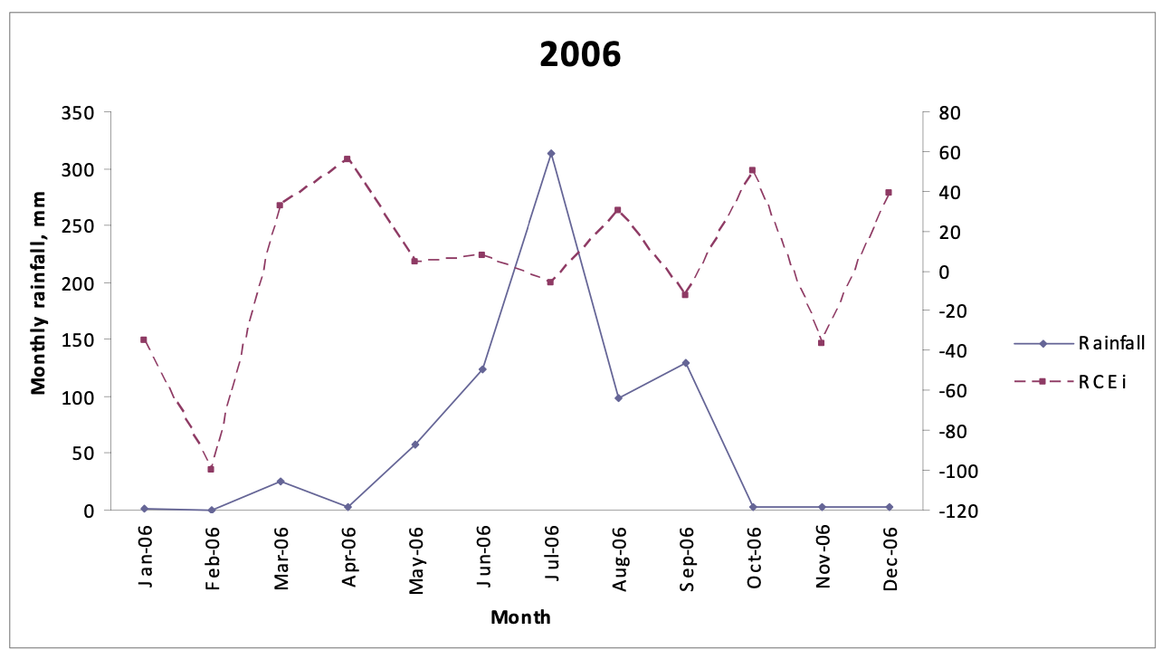

**Figure 1: Relationship of rainfall and rain crash effect.**

# Chapter 3

## Objectives

Investigate and explore several types of rain sensors available in the market. And to find a reliable one.

Understand the principles and working mechanisms behind various rain sensor technologies, such as resistive, capacitive, and optical sensors.

Evaluate the sensitivity, accuracy, and reliability of each sensor type to determine the most suitable one for the project.

Design a user-friendly interface, using an LCD screen or LED indicators, to display the current status of the rain sensor and wiper system.

Allow users to customize wiper settings, such as sensitivity levels and activation thresholds, to cater to individual preferences and driving conditions.

Avoiding and combatting errors by introducing redundancy

Designing a speed-controlled wiper mechanism when rainwater is detected and alert the driver

# Chapter 4

## Literature Review

Various types of rain sensors have been developed over the years to detect precipitation and trigger automatic wiper adjustments. The evolution of these technologies has led to more efficient and responsive systems for better driving experiences.

**Optical Rain Sensors**: Optical rain sensors utilize infrared light to detect water droplets on the windshield. When raindrops obstruct the infrared beams, the sensor triggers the wipers to activate. This type of sensor is known for its accuracy in detecting various levels of precipitation and can adjust wiper speed accordingly.

**Capacitive Rain Sensors**: Capacitive rain sensors measure changes in capacitance on the windshield surface caused by the presence of water droplets. The sensor triggers the wipers when a certain capacitance threshold is reached. These sensors are sensitive and responsive, providing an effective way to adapt wiper speed to the intensity of rain.

**Acoustic Rain Sensors**: Acoustic rain sensors use sound waves to detect the impact of raindrops on the windshield. The changes in sound patterns trigger the automatic adjustment of the wiper speed. This type of sensor is effective in distinguishing between rain and other debris, offering reliable performance in varying weather conditions.

**Piezoelectric Rain Sensors**: Piezoelectric rain sensors generate an electric charge in response to mechanical stress caused by raindrops. The change in charge activates the automatic wiper system. These sensors are known for their durability and responsiveness, making them suitable for harsh weather conditions.

# Chapter 5

## Methodology

This article proposes an automatic wiper system that turns on automatically when it rains and stops when it stops raining. This paper does not require physical human intervention to control the wipers of the car. In this post, we will use a servomotor, rain sensor arduino, and lcd module to control the wiper system. Whenever it rains, the rain sensor detects the intensity of the rain and sends that information to the arduino. The information collected by the rain sensor is processed by arduino and the processed information is sent to the servo motor to perform the desired action. The rain sensor consists of digital-to-analog output pins that calculate the intensity of the rain. The information sent to the microcontroller controls the speed of the wiper and is based on the intensity of the rain. The lcd shows the intensity of precipitation.

## 3.1 BLOCK DIAGRAM

The system consists of an Arduino uno board, a rain sensor, a servomotor and a lcd module. Block diagram of the proposed system in figure 3.1. The proposed system aims to remedy the shortcomings of existing systems. The wiper system consists of four stages. The first stage is a reading stage in which data is read from the rain sensor module. The second stage is the processing stage where the information from the sensor is processed. The third stage is the analysis stage, where the processed information is compared / analyzed. The fourth stage is the control stage, which controls the servo motor and lcd display. It uses Arduino uno and the language used is the Arduino programming language.

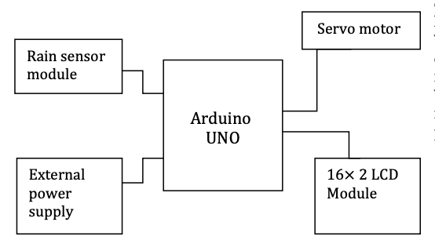

## 3.2 ARDUINO

Arduino is an easy-to-use type of software that you can use to write code to control hardware and electronic devices. The Arduino board can recognize inputs such as finger detection on sensors, light control in patterns, and finger placement on buttons. The light goes out. The Arduino uno microcontroller board can be controlled by sending instructions in code format. The code used here is based on Arduino programming. Use Arduino software for processing.

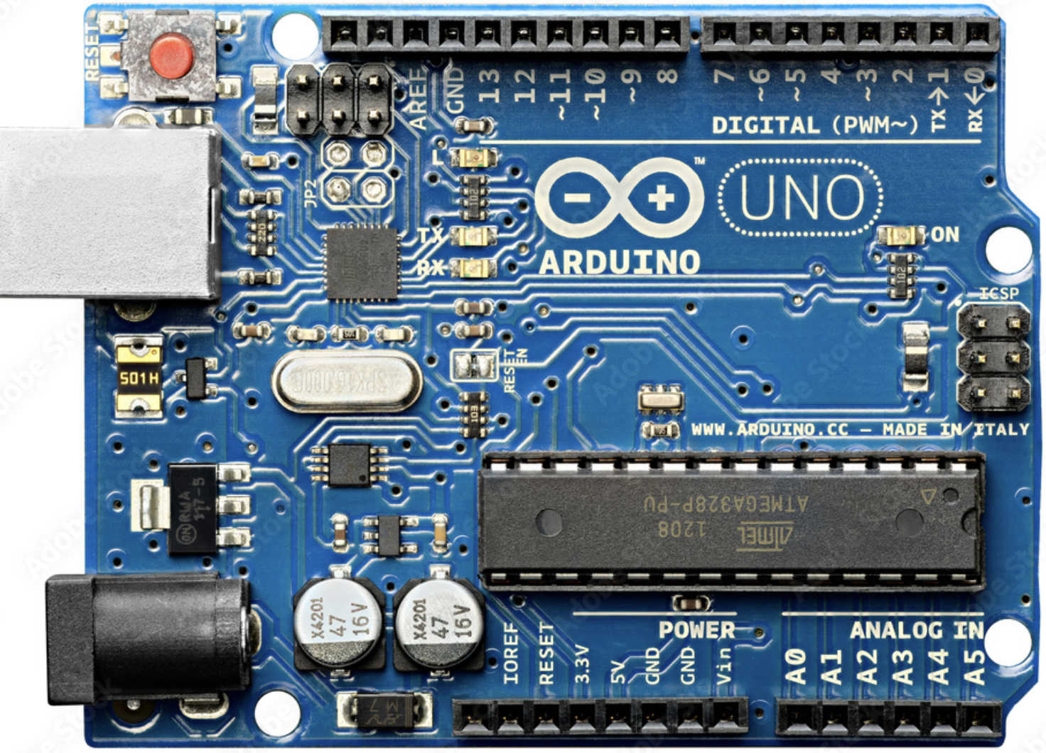

**Figure-2: Arduino uno**

## 3.3 RAIN SENSOR

A rain sensor is a device used to detect raindrops. These are electrically separated and can be used as printed circuit boards. The function of the rain sensor can be properly compared with the function of the switch. When it rains, the switch switches to off mode. When it rains the circuit closes and the resistance changes. They usually have zigzag track patterns to guide rain and waterfalls. This rain sensor unit consists of a rain board and a control board. It rains on a rainbow with two led lights. One shows the power supply and the other shows the rain. The second led light on the control board only flashes when a raindrop hits the rainbow. The rainbow is set to rain. Rain sensors are commonly used to detect precipitation droplets. Thresholds are defined for each rain sensor. When the droplet or moisture reaches the threshold limit, the rain sensor sends information to the person performing the desired action. The rain sensor is equipped with a digital-to-analog pin that can be used to record humidity. When the detected humidity exceeds the threshold, the desired action is taken. When the rain sensor is wet, it changes from 100000 to 2 m ohms and acts as a variable resistor. Therefore, if the board is wet, there will be more power lines. A0, d0, gnd, and vcc are analog, digital, ground, and positive voltages, respectively. The rain sensor is equipped with two loop pins, + and sensor board connectors a and b

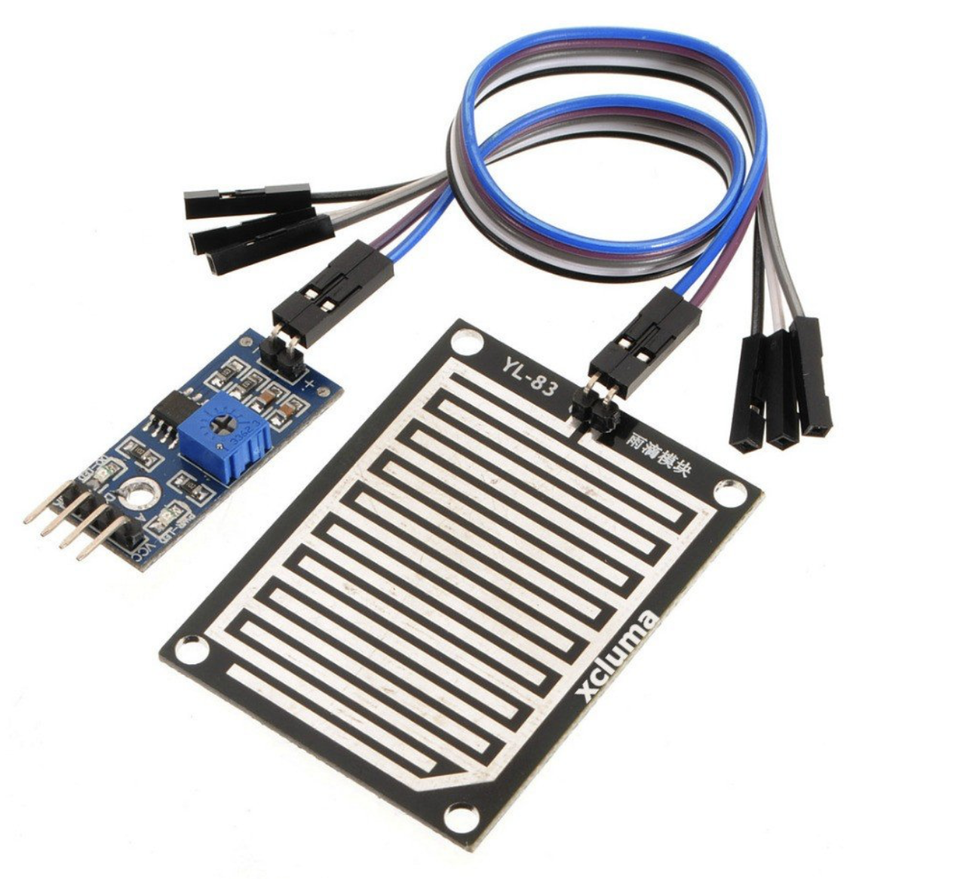

**Figure-3: Rain sensor**

## 3.4 SERVO MOTOR

Servo motors typically consist of output shafts that can be used to position the shaft at a particular angle using the coded signal transmitted by the servo. Servo motors are extremely useful in everyday life and are used in many devices. Servo motors are very efficient and economical. Servo motors are small and can be placed on the device to perform the desired action more effectively. Servo motors are very efficient and energy saving motors. These servo motors are controlled by pulse width modulation. Pulse width modulation uses a control wire to send an electrical pulse. The minimum, maximum pulse and repetition rate are three types of pulse width modulation. The total amount of movement of the servo motor is 180, and it rotates 90 in each direction. Servo motors rotate both clockwise and counterclockwise.

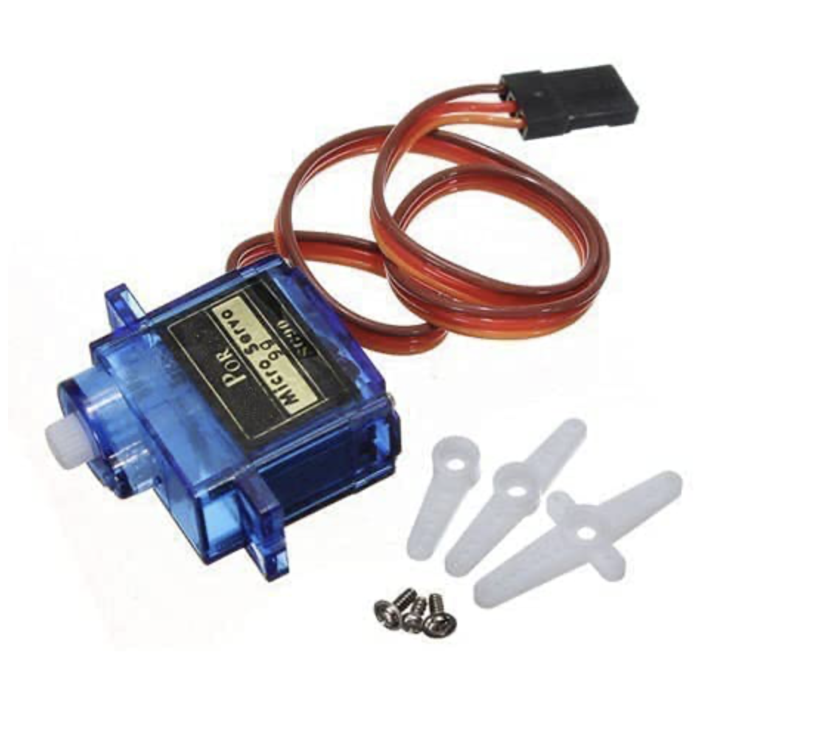

**Figure-4: servo motor**

## 3.5 working principle

### Rain sensing action

When it rains, the rain sensor has a water column or a water column, and the resistance changes. Therefore, the sensor acts as a variable resistance board. The relationship between rain intensity and resistance is inversely proportional to each other. As the number of raindrops increases, the resistance of the sensor decreases. The sensor then sends a signal, and the signal is received by the microcontroller. The microcontroller determines the intensity and transfers the signal to the servomotor in the form of pulse width modulation. After that, the wiper operation mode is turned on according to the rain strength. The sensor is designed so that its size does not obstruct the driver's view. The sensor is completely resistant to particles and elements from the environment that may come into contact with the sensor. Therefore, when such an event occurs, the sensor does not send a false alarm. I am trying to explain how a rain sensor works by using an example. Let us assume that the resistance of the remaining sensors is 1000k. In the case of light rain, the height of the water column of the rain sensor will be low because the intensity of the rain is weak. The resistance of the sensor drops, for example in the range of 900 to 400k. As precipitation increases, the raindrops accumulate on the sensor, reducing the resistance 300k to 100 k ohms. Resistance decreases with increasing rainfall. The drop in resistance is recorded as a signal that the Arduino uno microcontroller uses to determine the rain's intensity. The signal is sent to the servo motor, which operates and moves the wiper blades. The speed of the wiper increases as the strength increases.

### Combating false alarms

In our tests simulating real-life scenarios, we identified occasional errors in the system, attributed to atmospheric conditions and humidity. Furthermore, condensation from car air conditioning could result in water appearing on sensors, leading to false triggers. To address this, we implemented a solution involving two sensors positioned at a considerable distance from each other. The system is activated only when identical readings are obtained from both sensors, ensuring greater accuracy, and mitigating the impact of environmental factors.

### Lcd warning

To address the heightened risk of accidents caused by reckless driving in heavy rain, particularly due to vehicles skidding on wet roads, we have introduced a safety measure. This involves the integration of an LCD warning display and LED blinking system to alert drivers and enhance their awareness in adverse weather conditions.

# Chapter 6

## 6.1 Hardware result

The lcd module displays precipitation intensity from zero to low, medium, and high. If there is no precipitation, the lcd display will show the precipitation intensity as zero. When it starts to rain, the rain sensor will automatically detect the rain and send a signal to the lcd to show the intensity of the rain from low to high. When the precipitation intensity changes, the rain sensor detects the intensity and sends a signal to the servo motor, this increases the rotation speed.

6.2 Conclusion

The automatic wiper system is designed to detect rain and wipe the windows by moving the wiper. The automatic wiper system automates the purpose of the driver's response to control the wiper. The response of the rain sensor to rain to move the windshield wiper has been shown and proven to be less than 400 ms. The automatic car wiper was developed using a rain sensor and Arduino, but it can be expanded by replacing the rain sensor with an ir sensor to accurately identify and detect precipitation. When choosing an economical yet efficient wiper, the best way is to use a rain sensor. You can choose from a variety of sensors to serve this purpose as you move forward and change your system.

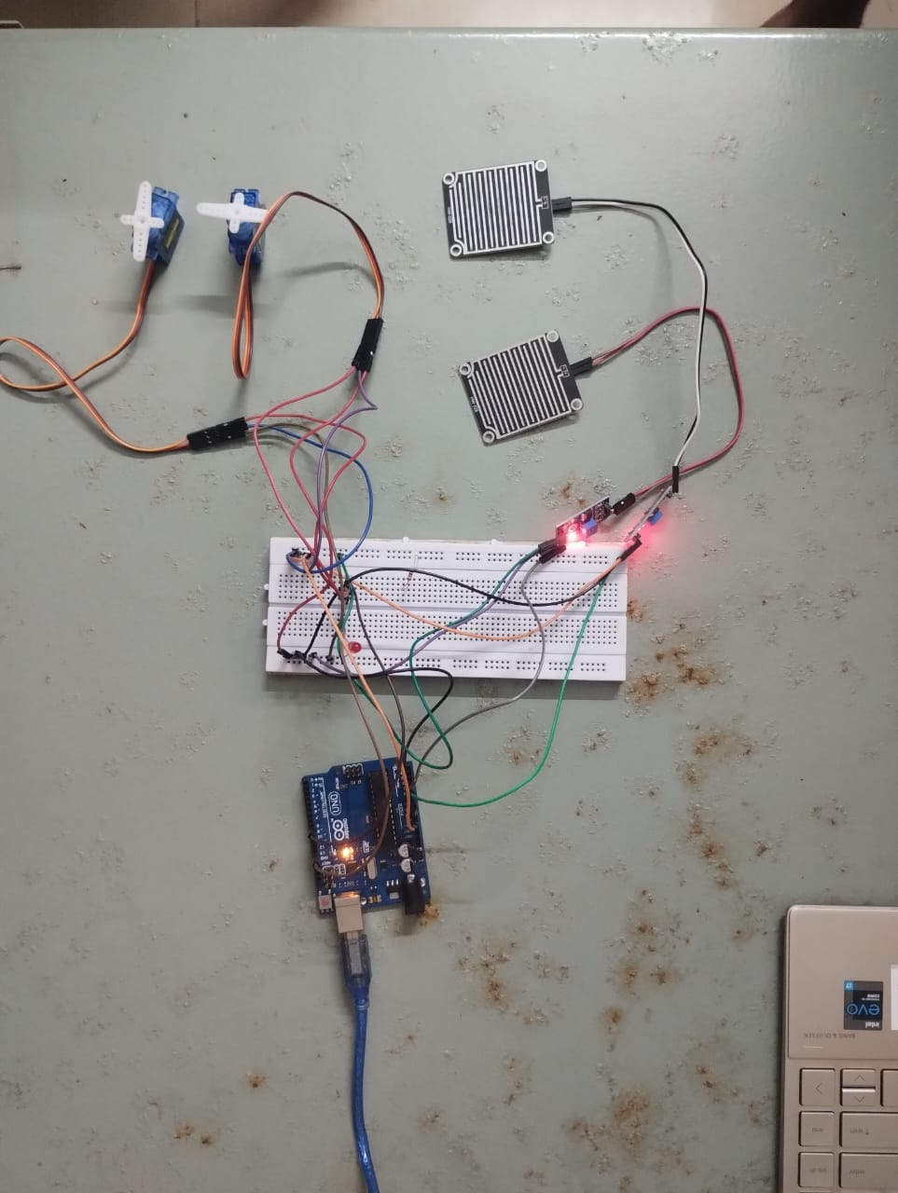

This is first case where there is no rain so no servomotor action

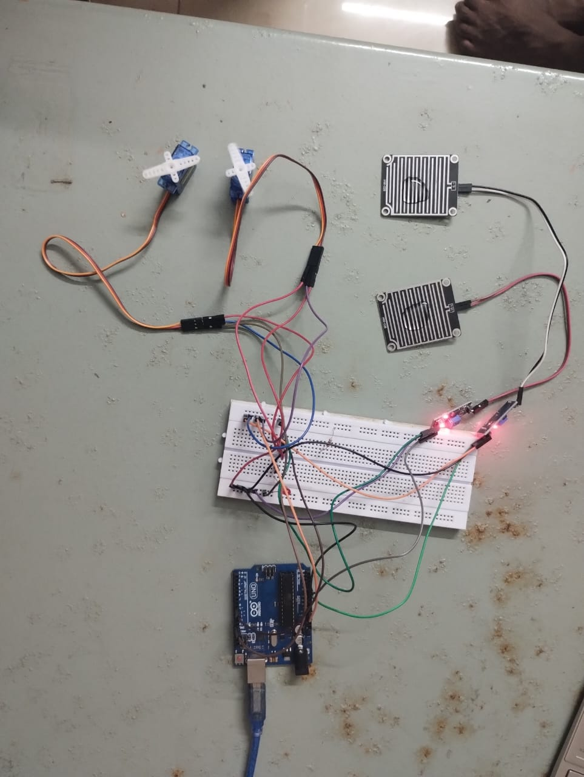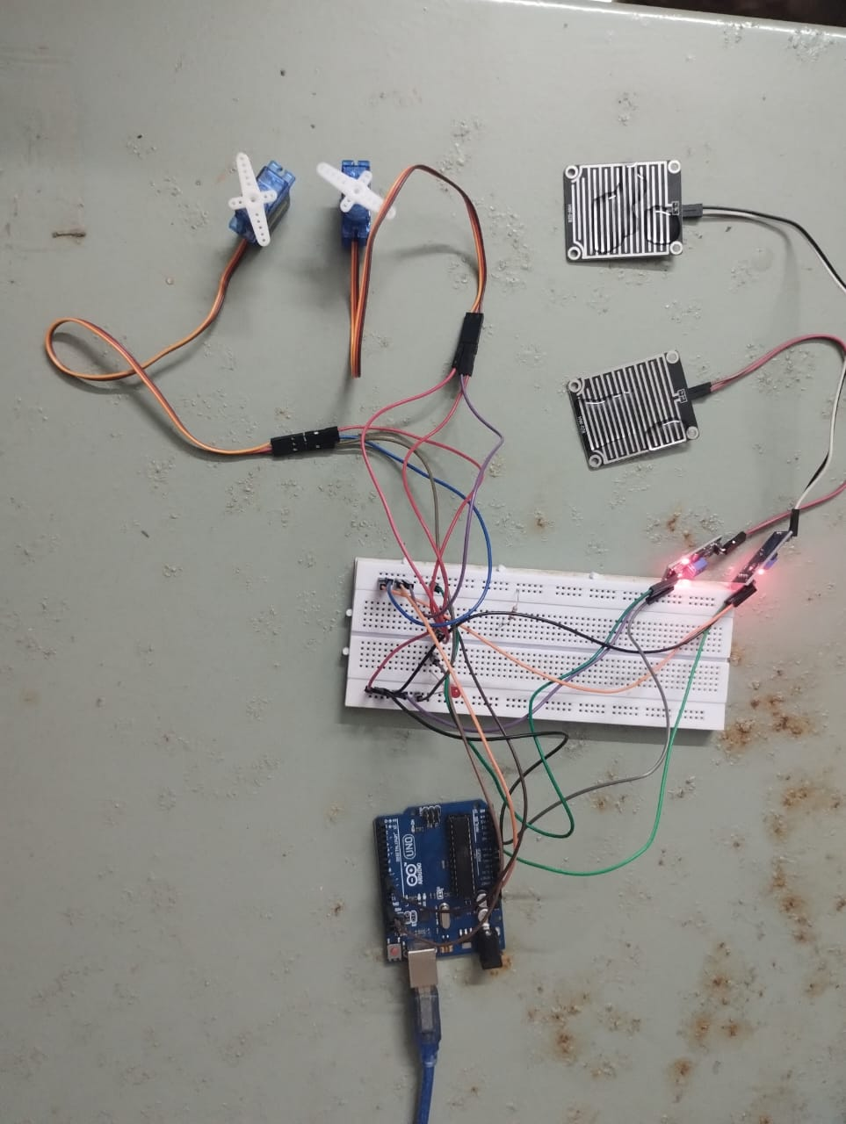

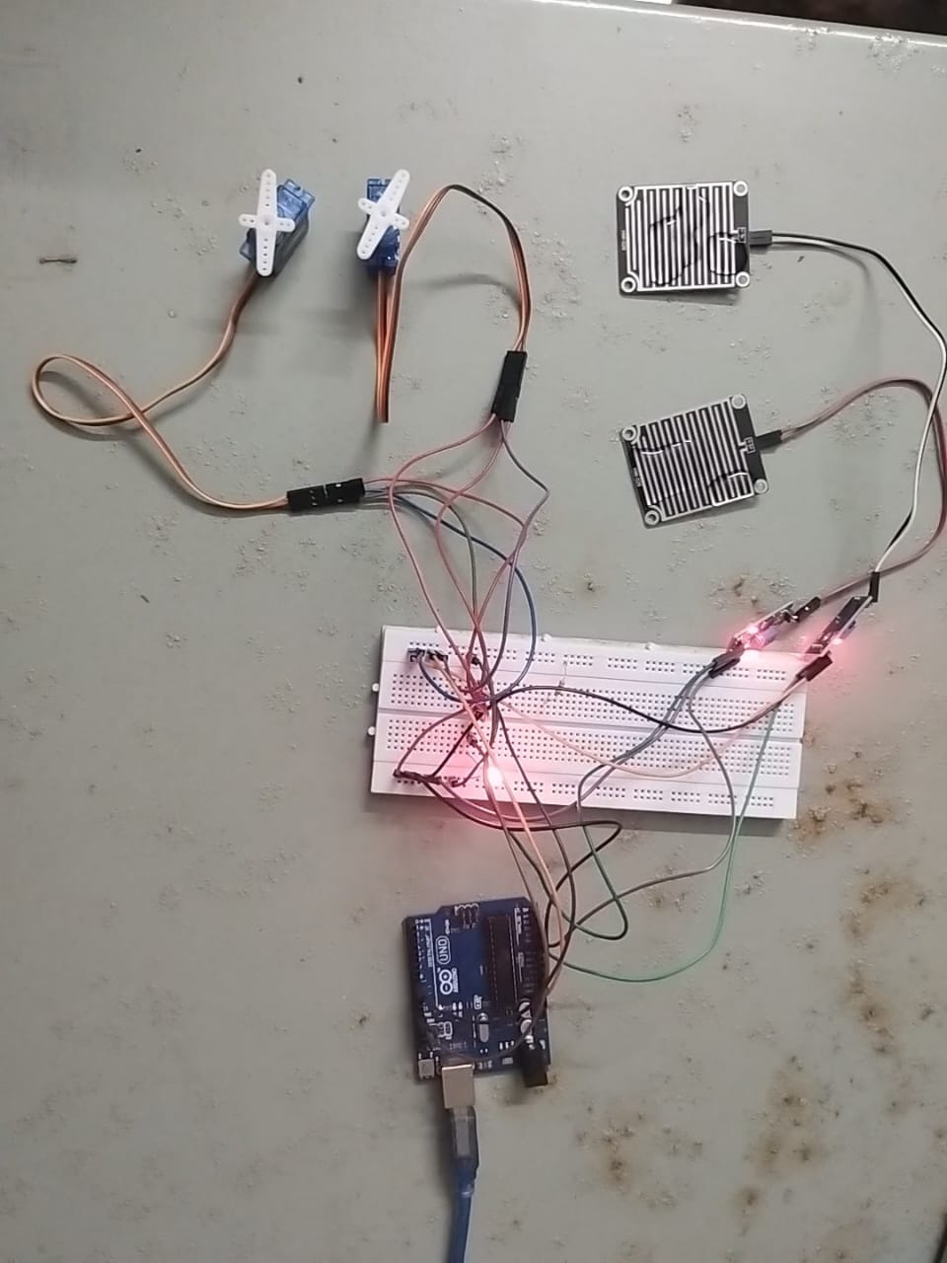

## Chapter 7

## 7.1 Future work

**Integration with Vehicle Systems:** Integrate the rain sensor with a vehicle's control systems, such as the anti-lock braking system (ABS) or traction control system. This integration can enable automatic adjustments in driving parameters to improve safety in rainy conditions.

**Wireless Connectivity**: Implement wireless connectivity options (Bluetooth, Wi-Fi, or cellular) to allow the rain sensor to communicate with other devices, such as smartphones or smart home systems. Users could receive real-time alerts or remotely monitor the sensor's data.

**Machine Learning for Predictive Analysis:** Employ machine learning algorithms to analyze historical rain data and predict potential hazardous conditions. This predictive analysis could enhance early warnings and allow for proactive measures to be taken.

**Energy-Efficient Operation:** Optimize power consumption to make the rain sensor more energy-efficient. This could involve using low-power components, sleep modes, or even harvesting energy from the environment (solar or kinetic) for sustainable and long-term deployment.

## 7.2 References

[1] automatic control of vehicles: an analysis by kushal sarin, jatin sethi, anshuman gupta, usha tiwari and ishan mathur ininternational journal of advanced research in computer and communication engineering april 2013

[2] automatic rain operated wiper system in automobile: a review by kothari mohit, shah amit, patel vipul and kadakia nishant in international journal for scientific research & development| vol. 3, issue 02, 2015| issn:2321-0613

[3] kadakianishant, a kothari, mohit a shah, amit v patel vipul r: automatic rain operated wiper system in automobile, international journal for scientific research & development vol. 3, issue 02, 2015

[4] Syed, ashfaq, smart rain detector using arduino (august 18, 2021). Available at ssrn: https: //ssrn. Com/abstract=3918326

[5] t. K. Gannavaram v, u. Maheshwar kandhikonda, r. Bejgam, s. B. Keshipeddi and s. Sunkari, "a brief review on internet of things (iot), " 2021 (iccci), 2021, pp. 1-6, doi:10.1109/iccci50826.2021.9457009

[6] k. V. Viswanadh, january-2015, design & fabrication of rain operated wiper mechanism using conductive sensor circuit, international journal of engineering research

[7]ayush kalra, sudhanshu srivastava, shivam pratap singh, prof. Sagar g. Mohite bharati vidyapeeth (deemed to be) university, college of engineering, pune- 411046, maharashtra issn:2320.2882